HORNE STREET SURGERY

PATIENT INFORMATION
LEAFLET

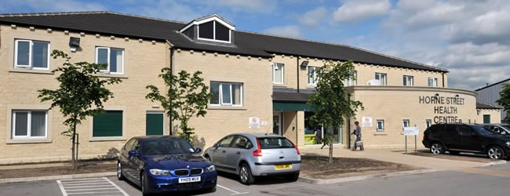

Dr. MUHAMMAD SUHAIL KHAN NIAZI (Male)
MBBS (Pakistan) DPD (UK 2011)
Date of Full Registration (2003)

Horne Street Surgery Disabled Access
Horne Street The practice has access for the
Halifax disabled on all consultation and
HX1 5UA treatment rooms/floor along with

Tel: 01422 357333 a patient Disabled Toilet

Website: www.hornestreetsurgery.co.uk

Practice Map

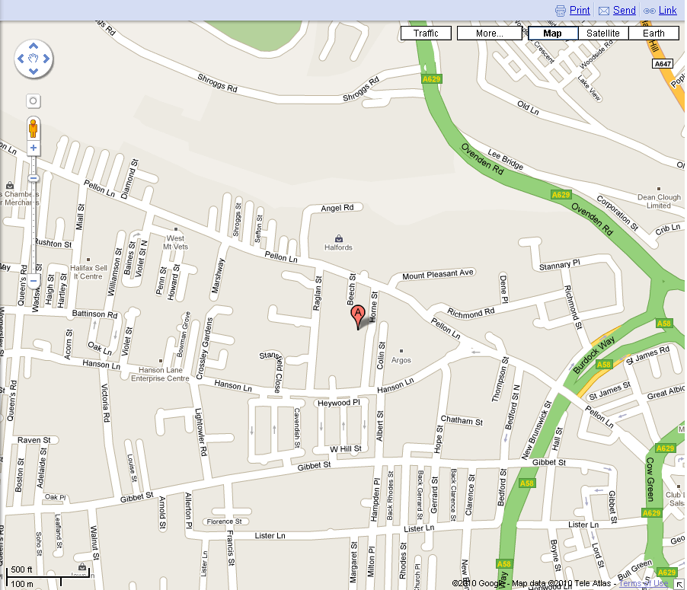

Directions to Surgery from M62

At junction 24 of M62, exit onto Blackley New Road/A629 toward Huddersfield/Halifax
At Ainley Top, take the 2nd exit onto Halifax Road/A629 bypass and follow the road straight past Calderdale Royal Hospital (on your left hand side) and through a further set of 4 traffic lights.
Follow road to traffic lights at Halifax Building Society (on left hand side) and follow road to next set of traffic lights at the roundabout, take the 2nd exit onto Cow Green/A629.
At traffic lights turn left onto Pellon Lane
Turn left onto Hanson Lane
Turn right onto Horne Street

WELCOME TO HORNE STREET SURGERY

Horne Street Surgery offers a professional caring service for all your healthcare needs

Dear Patients

The doctors and staff at Horne Street Surgery in Halifax are proud to offer the highest standard of patient-centred healthcare. We run many clinics for the management of chronic diseases such as asthma and diabetes and offer a wide variety of other medical services including antenatal and postnatal care, minor surgery, childhood vaccinations and well-person check-ups. New patients who live in our catchment area are more than welcome to join us!
We are a PMS practice. The practice consists of one doctor.
- Dr M S K Niazi MBBS DPD

The surgery provides the following services:-
- Health Promotion and Screening Clinic
- Diabetes
- Heart Disease Prevention
- Asthma
- Minor Surgery
- Mental Health
- Epilepsy
- Smoking
- Obesity
- Cervical smear
- Contraception and Hormone Replacement Clinic
- Child Health Screening under five and all childhood immunisation
- Medical and Travel immunisation approved by the Department of Health

We would like you to make full use of these services.

It is advisable to keep this leaflet near to your telephone.

Surgery Hours

The Practice is open 54.5 hours between Mondays to Friday

Surgery Opening Hours
Monday - Friday: 08.00am - 18.30pm
Tuesday (extended Hour) 08.00pm – 20.30pm

Consultation Hours GP and Advanced Nurse Practitioners
By Appointment only
 | Monday | Tuesday | Wednesday | Thursday | Friday
Dr Niazi | 09.00 – 12.00  16.00 – 18.00  (Alternate) | 09.00 –12.00  16.00 –18.00  18.30 –19.30 | 09.00 – 12.00 | 09.00 –12.00  16.00 –18.00 | 09.00 –12.00  16.00 –18.00  (Alternate)
Eileen Kay  ANP | 09.00 – 12.00  14.00 – 17.00 | 09.00 – 12.00  14.00 – 17.00
Subhan Khan ANP |  |  | 09.00 – 12.00  14.30 – 17.30 | 09.00 – 12.00  15.00 – 16.00
S Akhtar  Phlebotomy | 09.00 - 11.00 |  |  | 09.00 - 11.00 | 09.00 - 11.00

Consultation Hours Nurse and Healthcare Assistant (HCA)
By Appointment only
 | Monday | Tuesday | Wednesday | Thursday | Friday
Val Clegg  PN | 08.00 – 13.00 | 08.00 –17.00 | 08.30 – 16.30 | 09.00 –16.00 | 08.00 –16.00
Vijaya HCA | 13.45 - 14.45 |  | 09.00 – 12.30

Locum Doctor
We use locum doctors from time to time when the GP is on annual leave or off sick.

Surgery Staff
General Practitioner Dr Muhammad Suhail Khan Niazi (MBBS)
(Male) (Child health surveillance, Diabetes review, Chronic Diseases reviews, Minor Surgery)
Practice Manager Shama Hussain
Practice Nurse Val Clegg
Advanced Nurse Eileen Kaye
Practitioners Subhan Khan
Phlebotomist Shamim Akhtar
Healthcare Assistant Vijaya Deverapalli
Practice Assist
(telephone consultations only)
Medical Secretary Anju Sethi

Practice staff also consists of an administrative and receptionists team. They are here to help you with anything to do with the organisation of the Practice. Please do not hesitate to ask any of the staff if you need further information.

Appointments

The doctor and nursing team run surgeries and clinics at various times between 08:00 and 18:30 Monday to Friday.
Note: - Consultations are by appointment only.

We strive to maintain 48 hour access to our medical team for all patients so we need to limit the number of appointments we make available for advance booking, therefore the majority of appointments for the GP are “book on the day” this also includes telephone consultation appointments.

Nurse’s appointments are mainly bookable in advance.

Each appointment is for one person only with one medical problem. If you have a number of concerns that you need to discuss, further appointment time will be necessary. Please advise reception of your needs when booking your appointment.

The reception team are responsible for managing the allocation of appointments and to do this effectively they will ask for details. The receptionist needs only the briefest detail to be able to direct patients to the most suitable clinician (Doctor, Practice Assist, Practice Nurse, Advanced Nurse Practitioner or phlebotomist).

Note: - Patients will NOT be seen without an appointment unless it is a medical emergency. If you arrive late for an appointment we cannot guarantee that you will be seen, you may need to make another appointment.
If you cannot keep a booked appointment please telephone the surgery as soon as possible so that the appointment time can be allocated to another patient.
The surgery also offers “ring-backs” for patients who may require urgent medical assistance but no appointment is routinely available or requires urgent service. This service involves the GP calling the patient on the phone after their morning clinic. Messages cannot be left on answer machines therefore it is vital that you can give a telephone number where you can be contacted.

Online Services

Before being able to use the online service patients must firstly register in person at the Practice by completing the necessary paperwork (available at the practice) and producing identification i.e. Photo ID, Utility bill, Bank Statement, Council Tax bill etc.
Services available online:-
- Repeat prescriptions
- Booking Appointments - available to pre-book up to 4 weeks in advance. These are standard 10 minute consultations for non-urgent problems. For urgent problems please contact the surgery.

Currently this service only applies to doctor’s appointments. We are unable to offer nurse appointments online due to the diverse range of appointments and staff that are bookable.
If you need to book to see a nurse you will need to contact the surgery. We will only allow 1 appointment to be booked in advance at one time. This is to avoid appointments being booked ‘just in case’.

DNA (Did not attend)
The surgery’s strict policy is that after 2 DNA’s, the patient will receive a warning letter from the practice, after the 3rd DNA patient will be remove from list.

Home Visits

Please try to telephone reception before 10.00am if you require a home visit, the GP may phone you back as it may be that your problem can be dealt with by telephone advice, or that it would be more appropriate to send a nurse, or indeed arrange a hospital attendance.
Home visits are only available for patients who are housebound because of illness or disability.

Please remember that several patients can be seen in the practice in the time that it takes to make one home visit. There are also better facilities for examining and treating patients at the practice

Text Messaging

The surgery sends text messages to remind patients of booked appointments, to confirm appointments, to invite patients for review and to update patients with relevant news. No personal details will be sent in a text. Please ensure we have your up to date mobile number. You may OPT OUT of the text service at any time by advising reception.

Horne Street Health Centre NHS Walk-in Centre

You can also see a GP or Nurse Practitioner for treatment of minor injuries and illnesses at Horne Street Health Centre NHS Walk-in Centre. You do not need an appointment.
They are open from 8:00 to 20:00 Weekends and Bank Holidays.

Note: - this service is provided by Locala and not Horne Street Surgery.

If your first language is not English

Some of our staff speaks additional languages to English. The Practice has access to Language Line, which is a telephone service that aids us in the interpretation of different languages. We are also able to book the services of an Interpreter/Link worker to help during consultations - this service needs to be booked in advance. Please indicate to a receptionist if you need this sort of assistance

Test Result

If you have had any investigations performed such as blood or urine tests or X-rays, it is your responsibility to contact the surgery for the results. You can call in person or telephone on the surgery number at less busy hours preferably 12.00 – 3.00pm. You may be asked to provide some means of identification. The reception staff are not qualified to interpret results and will only tell you what has been authorised by the doctor. The GP receives these results electronically on link and take appropriate action, if don’t hear from us this means results are normal. Should the results show any abnormalities the GP will provide a prescription or ask you to make an appointment at the surgery.
Change of Address and Telephone Number

If you change your name, telephone number or address (even for a short time), let us know immediately. You can do this by calling in and filling in the appropriate form.

NHS 111 Out of Hours

In the case of urgent need when the practice is closed you can call NHS 111. NHS 111 will assess you, provide advice and direct you straight away to the local service that can help you best. NHS 111 is available 24 hours a day, 7 days a week and calls are free, including from mobiles.

Call 999 in an emergency. Chest pains and/or shortness of breath constitute an emergency.

Accident & Emergency (A&E)

A&E departments assess and treat patients with serious injuries or illnesses. Generally, you should visit A&E or call 999 for emergencies, such as:-

- loss of consciousness,
- pain that is not relieved by simple analgesia,
- acute confused state,
- severe chest pain, or
- Breathing difficulties.

If you are unsure then please feel free to ring the practice for advice.

Repeat Prescriptions
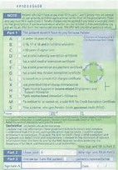
To make sure patients receive the right prescription and ensure patient safety, we do not accept telephone request for repeat prescription.

- Complete the back of your prescription and post it to the surgery prescription box which is located near the reception window.
- Your prescription will normally be available after 48 hours (normally after 2pm on the second working day following your request).
- Prescription posted in on a Friday will be ready to collect on Monday afternoon.
- Please do not wait until you have finished your medication before re-ordering.
- If you need to make an appointment, please try to book it before your prescription runs out.
- Alternatively, you may post your request to the surgery along with a stamped self-addressed envelope.

Electronic Prescriptions

The Electronic Prescription Service (EPS) is an NHS service. It gives you the chance to change how your GP sends your prescription to the pharmacy you choose to get your medicines or appliances from.

How can you use Electronic Prescription?

You need to choose a place for your GP practice to electronically send your prescription to. This is called nomination. You can choose:-
- A pharmacy.
- A dispensing appliance contractor (if you use one).

Ask any pharmacy or dispensing appliance contractor that offers EPS or your GP practice to add your nomination for you. You don’t need a computer to do this.

Private Prescription

Any patient, who has seen a clinician privately, or at a private hospital, must get their prescription from that hospital. IT CANNOT BE TRANSFERRED TO AN NHS SCRIPT.
If you have any queries, please ask the Practice manager or Receptionist.

Prescriptions Charges and Exemptions

Extensive exemption and remission arrangements protect those likely to have difficulty in paying charges (NHS prescription and dental charges, optical and hospital travel costs).
The NHS prescription charge is a flat-rate amount which successive Governments have thought it reasonable to charge for those who can afford to pay for their medicines. Prescription prepayment certificates (PPCs) offer real savings for people who need extensive medication.

NHS charges

These charges apply in England only. In Northern Ireland, Scotland and Wales prescriptions are free of charge.
- Prescription (per item): £8.60
- 12-month prepayment certificate (PPC): £104.00
- 3-month PPC: £29.10
If you have to pay for four or more prescription items in three months or more than 14 items in 12 months, you may find it cheaper to buy a PPC.

There is further information about prescription exemptions and fees on the NHS website

Non NHS/Private Services

There are certain services that doctors provide which do not come under the NHS jurisdiction and therefore doctors provide these privately for a charge. These services may include provision of letters, insurance reports, medical examinations, certificates, etc. Please check with Reception for up to date charges. The doctor’s clinical NHS work must take priority and in light of this, we would advise patients to give the doctor approximately one week to complete any reports etc.

New Patient Registration

Horne Street Surgery welcomes everyone who moves into or lives in the practice area who wishes to register with us.

Patients who wish to register must live within the practice boundary. The practice may refuse an application to join the practice if you do not reside in our area. We will not refuse to accept you on the grounds of race, gender, social class, age, religion, sexual orientation, appearance, disability or medical condition. We only refuse to accept new patient when the patient has been previously removed from our practice list or the patient has a known history of violence. In any case the patient will be informed within two weeks after receiving GMS1.
Please bring in your signed medical cards and complete the practice registration forms for each person requesting to join the practice, this includes a health questionnaire. This form can be uploading from our website.

All new patients will be asked to attend a ‘new patient health check’ appointment with the practice nurse. If you have a medical condition or you are on repeat medication the ‘new patient health check’ should be booked with a GP as well. It is essential that you attend this appointment to enable us to evaluate your medical requirements, discuss any concerns and your medication.

Health Check

All new patients are offered a check up on joining the practice. This service is also offered to all patients between 15 and 74 years who have not been seen by the doctor in the past three years.

We offer an annual check up to patients over the age of 75 years in their homes if they are unable to attend the surgery.

Sickness Certificates

You do not require a doctor's sickness certificate for any illness lasting seven days or less. Your employer may however require you to complete a self-certification form (SC2) which is available from your employer or on the HMRC website.

Statement of Fitness for Work - ’Fit Note'

The 'fit note' was introduced on 6 April 2010. With your employer's support, the note will help you return to work sooner by providing more information about the effects of your illness or injury.

For more information see the DirectGov website (where this information was sourced)

Access to your Medical Record

In accordance with the Data Protection Act 1998 and Access to Health Records Act, patients may request to see their medical records. Such requests should be made through the Practice Manager/Medical Secretary and may be subject to an administration charge for the administration and time involved. No information will be released without the patient consent unless we are legally obliged to do so.

Should your doctor decide that seeing your records might put your health at risk, you may only be shown part of your records or your request may be declined?

Access to Patient Information

In any case no information is disclosed without the prior written permission of the patient, to any organisation except for research or survey purposes. In these cases we use the data without disclosing the identity of the patient.

Sharing your Medical Record

In some instances, you may be receiving care from other people as well as the NHS. We may need to share some information about you with them, so that we can all work together for your benefit. Anyone who receives confidential information about you from us is under a legal duty of confidence. Unless there are exceptional circumstances, for example, when the health or safety of others is at risk, we will not disclose your information to third parties without your permission.

In certain circumstances we are required by law to report information; however our guiding principle is that we are holding your records in strict confidence.

You may ask us to share your health record with agencies e.g. solicitors, insurance companies, we will only do this with your written consent, and you may ask to view this information before it is provided.

Freedom of Information

Information about the General practitioners and the practice required for disclosure under this act can be made available to the public. All requests for such information should be made to the practice manager.

Zero Tolerance Policy

The NHS operate a zero tolerance policy with regard to violence and abuse and the practice has the right to remove violent patients from the list with immediate effect in order to safeguard practice staff, patients and other persons. Violence in this context includes actual or threatened physical violence or verbal abuse which leads to fear for a person’s safety. In this situation we will notify the patient in writing of their removal from the list and record in the patient’s medical records the fact of the removal and the circumstances leading to it.

Family Planning

The practice provides full contraceptive services including emergency contraception.

Maternity Service

This service is offered by either the midwife led care GP maternity unit in Calderdale Royal Hospital under Dr Niazi and his attached midwife or under shared care with a specialist obstetrician. Please make an appointment by ringing (01422, 342552) at Jubilee Children Centre, Lightowler Road, Halifax, HX1 5NB.

Either a doctor or a nurse will be happy to advise you on any concerns you may have.

Child Health Surveillance

The practice provides comprehensive child health surveillance for children registered with the practice, shared with the health visitor.

Baby clinic is on every Thursday mornings 9.30am – 1.00pm. Appointment is necessary. The clinic is staffed by a GP and Practice Nurse. The clinic provides developmental checks, immunisation and weighing- or just an opportunity for a chat about your baby. This is a well-baby clinic so an ordinary GP surgery appointment should be made if your baby is sick.

Chaperons

All patients are entitled to have a chaperone present for any consultation, examination or procedure where they feel one is required. The doctor may also request to have a chaperone present. Before any examination is performed, you will be asked if you would like a chaperone present, if yes, a member of the practice team will be asked to enter

Hospital Referrals/e-Referral (previously known as Choose and Book)

e-Referral enables patients to choose a convenient place, date and time for their initial hospital appointment. Patients will be able to choose from one to four hospitals (or other healthcare provide facilities) commissioned by their CCG.
Information on these hospitals will be provided to GP staff and patients at www.nhs.uk to enable them to choose.

You will be given an information sheet with TWO IDENTIFIERS – a BOOKING NUMBER and a PASSWORD both unique to you. This information will be needed when you telephone the outpatients appointments telephone number to book an appointment. We shall highlight these important identifiers for you.

This system will help you arrange an appointment time to suit YOU best and you will have the reassurance of a definite booking much sooner.

Should you have any difficulties when trying to make a hospital appointment, do not hesitate to contact the surgery, staff here will be happy to help you.
If you have private medical insurance and wish to be referred privately, please ensure the GP is aware of this.

Hospital Appointments

It is strongly recommended to keep hospital appointments. If you are unable to attend please ring the hospital at least a week in advance. If you need transport, you can make a request at reception at least a week before your appointment.

Please take all your medications with you when attending hospital for any reason.

Computer Records

The practice records the majority of the information it obtains about patients in a computerised record. The system used by the practice is part of the NHS Digital programme for IT. Access to patient identifiable information is strictly controlled by local and national confidentiality controls. Access is only allowed to people directly involved in the patients care. The practice takes confidentiality very seriously and maintains strict controls over access to information.
Travel Advice

The practice provides appropriate immunisations under NHS. Please make an appointment with the practice nurse at least three weeks before you travel.

Comments, Suggestions and Complaint

We welcome your comments and suggestions on the quality and type of service provided by this Practice. There is a suggestion box in the waiting area or you can write directly to the Practice Manager.

If you have any complaints regarding our services or a member of the team, please contact the Practice Manager, either in person, in writing or by telephone. We take complaints seriously and have a practice complaints procedure which meets standards required nationally by the NHS. We have a leaflet explaining the details, which you can obtain from reception.

Mobile Phones

We would respectfully ask in consideration of other patients in the surgery, that your mobile phone is switched off whilst you are in the surgery building. If you need to make a call, there is a payphone in Reception or you may use the entrance porch to use your mobile phone.

Carers

We are interested in identifying carers, especially those people who, whatever their age, may be caring without help or support. We know that carers are often “hidden” looking after a family member or helping a friend or neighbour with day-to-day tasks and may not see themselves as a carer.

As a carer, you are also entitled to have your needs assessed by Social Services. A Carer’s Assessment is a chance to talk about your needs as a carer and the possible ways help could be given. It also looks at the needs of the person you care for. There is no charge for an assessment.

Confidentiality & Medical Records

The practice complies with data protection and access to medical records legislation. Identifiable information about you will be shared with others in the following circumstances:-

- To provide further medical treatment for you e.g. from district nurses and hospital services.
- To help you get other services e.g. from the social work department. This requires your consent.
- When we have a duty to others e.g. in child protection cases. Anonymised patient information will also be used at local and national level to help the Health Board and Government plan services e.g. for diabetic care.

If you do not wish anonymous information about you to be used in such a way, please let us know. Reception and administration staff requires access to your medical records in order to do their jobs. These members of staff are bound by the same rules of confidentiality as the medical staff.

Confidentiality for the under 16’s

Teenagers are entitled to the same confidentiality as adults; this includes children over thirteen years of age providing the doctor or nurse feels they are capable of making decisions about their own health. All practice staff including receptionists following strict guidelines to ensure patient confidentiality.

The Patient Advice and Liaison Service (PALS)

PALS can provide confidential, on-the-spot advice and support, helping you to sort out any concerns you may have about care we provide, guiding you through the different services available from the NHS. The service can be contacted on 0800 0525 270 or by emailing WestYorksPALS@nhs.net.

Campaign launched to reduce prescribing of over-the-counter medicines

To help reduce this, Calderdale CCG has launched a campaign to lessen the amount of these medicines prescribed by GPs.

This campaign will not stop the prescribing of any medicines; it’s aim is to encourage patients to buy over the counter medicines that can be used to treat common ailments rather than get them on prescription, and maintain a stock at home to take when they need it.

People who have the need for regular medication such as paracetamol and ibuprofen because of long term medical conditions will still be able to get them on an NHS prescription.”

You can help us make best use of NHS resources by:-

- Not asking your GP to prescribe medicines you can get over the counter in your local shop, supermarket or pharmacy, such as paracetamols and antihistamines
- Getting advice from a pharmacist as soon as you start to feel unwell
- Keep a well-stocked first aid kit at home to help deal with minor injuries
- Attending GP appointments, and cancelling appointments you no-longer need

Referral to Local Pharmacy - no Prescription Required

You have a common condition that can be treated with a medication that is available to buy over the counter from your local pharmacy.

You do not need to make an appointment to speak to the pharmacist, just pop in anytime and they will be happy to help you.

Ask the pharmacist for help and advice on the most appropriate medication to relieve your symptoms for:-
coughs and colds |  | toothache |  | aches and pains
sore throat |  | headache and migraine |  | teething
hayfever and allergies |  | conjunctivitis |  | sleep problems
skin rashes |  | fungal nail infections |  | travel sickness
heartburn and indigestion |  | fungal skin infections - ringworm |  | threadworm
upset stomach |  | Piles (haemorrhoids) |  | head lice
constipation |  | diarrhoea |  | athlete’s foot
colic |  | cold sores

If at any time you are concerned about your condition or if your symptoms are not improving after a few days of treatment with the over the counter medications you should contact the local pharmacist or the surgery for more advice.

For more information visit:-
http://www.nhs.uk/Livewell/Pharmacy/Pages/Commonconditions.aspx

NHS Health Check
What is an NHS Health Check?

The NHS Health Check is a health check-up for adults in England aged 40-74. It's designed to spot early signs of stroke, kidney disease, heart disease, type 2 diabetes or dementia. As we get older, we have a higher risk of developing one of these conditions. An NHS Health Check helps find ways to lower this risk.
How do I get an NHS Health Check?

If you're in the 40-74 age group without a pre-existing condition, you can expect to receive a letter from your GP or local authority inviting you for a free NHS Health Check every five years.

Will I get my NHS Health Check from my GP?
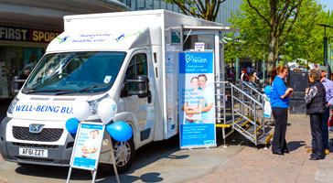
Because the NHS Health Check programme is run by local authorities, how you get your check varies, depending on where you live.
While the NHS Health Check is usually done in GP surgeries and local pharmacies, they may also be offered at other suitable and accessible places in your area.
For example, in some areas NHS Health Checks are offered to passers-by at mobile units, while in other places they have been offered at leisure centres.
On the day of your NHS Health Check
The Check itself is carried out by a health professional. This will usually be a nurse, but it could also be a doctor, pharmacist or healthcare assistant. The entire process takes about 20-30 minutes. You will be asked some simple questions, including:-

- whether any of your close relatives have had the illnesses being checked for
- if and how much you smoke
- how much alcohol you drink, if any
- what your diet is like
- how much physical activity you do

The following simple tests will also be carried out:-

- Your weight and height will be measured to work out your body mass index (BMI).
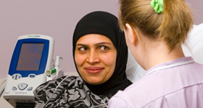
- Your waist may also be measured using a tape measure.
- Your age, gender and ethnicity will be noted.
- Your blood pressure will be taken using a cuff fitted over your upper arm – find out what happens during a blood pressure test.
- You will have a small prick of blood taken from your finger to check your cholesterol level and possibly also your blood sugar level

How can I improve my test results?

Once you've had your NHS Health Check, your healthcare professional will discuss your results with you. You'll be given advice to help you lower your risk of a stroke, kidney disease, heart disease, diabetes or dementia, and maintain or improve your health.

Health Checks for Patients over the age of 75

Horne Street Surgery also provides annual health checks for patients aged 75 and over. Patients are invited to attend the surgery where their blood pressure, weight, residential status, next of kin, current medical condition and medication are assessed/updated.

Invitation for these appointments are sent out via a letter from the practice; followed by two telephone calls if no response has been received from the patient.

It is important that patients take full advantage of these health checks, the Doctor/Nurse will get to know you and understand your health needs/concerns, following up on any problems identified.

Useful Telephone Numbers

Services | Tel No | Role
NHS 111 | This is a Free phone number from both landline and mobile | If you require health information or advice, NHS 111 is a 24 hour nurse’s advice line is available.
District Nurses Based at  St Johns Health Centre | 01422 361374 | A team of District nurses attached to the practice provide home care when needed.
Health Visitor Based at St Johns Health Centre | 0300 3045076
Community Midwife  Based at Jubilee Centre | 01422 360336
Social services | 01422 363561 | Main role is to identify the care needs of people living in Calderdale and to provide cost effective, quality services which safeguard and promote the wellbeing of those people in greatest need.
Dental Problems | 0845 1220221

